**Question1**

**Create a function that takes three integer arguments (a, b, c) and returns the amount of integers which are of equal value.**

**Examples**

**equal(3, 4, 3) ➞ 2**

**equal(1, 1, 1) ➞ 3**

**equal(3, 4, 1) ➞ 0**

**Notes**

**Your function must return 0, 2 or 3.**

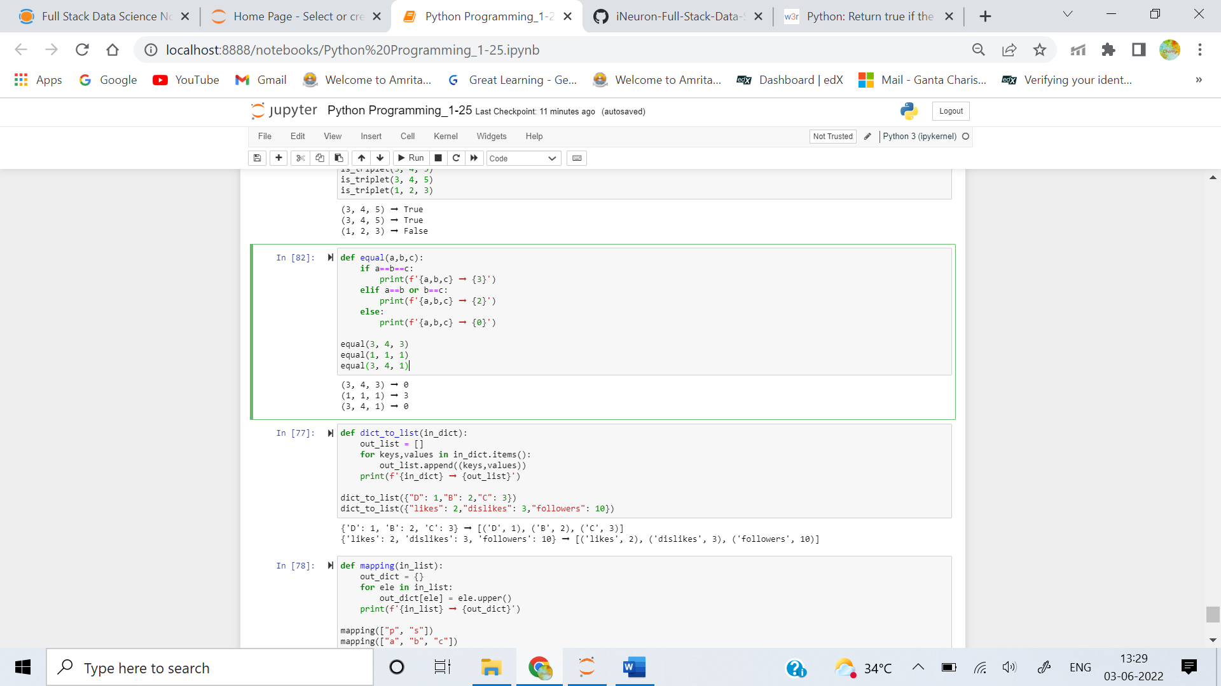

**Question2**

**Write a function that converts a dictionary into a list of keys-values tuples.**

### Examples

**dict_to_list({**

**"D": 1,**

**"B": 2,**

**"C": 3**

**}) ➞ [("B", 2), ("C", 3), ("D", 1)]**

**dict_to_list({**

**"likes": 2,**

**"dislikes": 3,**

**"followers": 10**

**}) ➞ [("dislikes", 3), ("followers", 10), ("likes", 2)]**

### Notes

**Return the elements in the list in alphabetical order.**

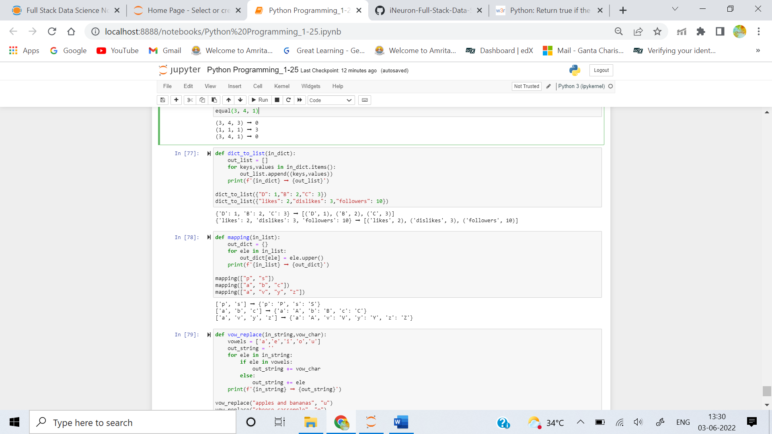

**Question3**

**Write a function that creates a dictionary with each (key, value) pair being the (lower case, upper case) versions of a letter, respectively.**

### Examples

**mapping(["p", "s"]) ➞ { "p": "P", "s": "S" }**

**mapping(["a", "b", "c"]) ➞ { "a": "A", "b": "B", "c": "C" }**

**mapping(["a", "v", "y", "z"]) ➞ { "a": "A", "v": "V", "y": "Y", "z": "Z" }**

### Notes

**All of the letters in the input list will always be lowercase.**



**Question4**

**Write a function, that replaces all vowels in a string with a specified vowel.**

### Examples

**vow_replace("apples and bananas", "u") ➞ "upplus und bununus"**

**vow_replace("cheese casserole", "o") ➞ "chooso cossorolo"**

**vow_replace("stuffed jalapeno poppers", "e") ➞ "steffed jelepene peppers"**

### Notes

**All words will be lowercase. Y is not considered a vowel.**

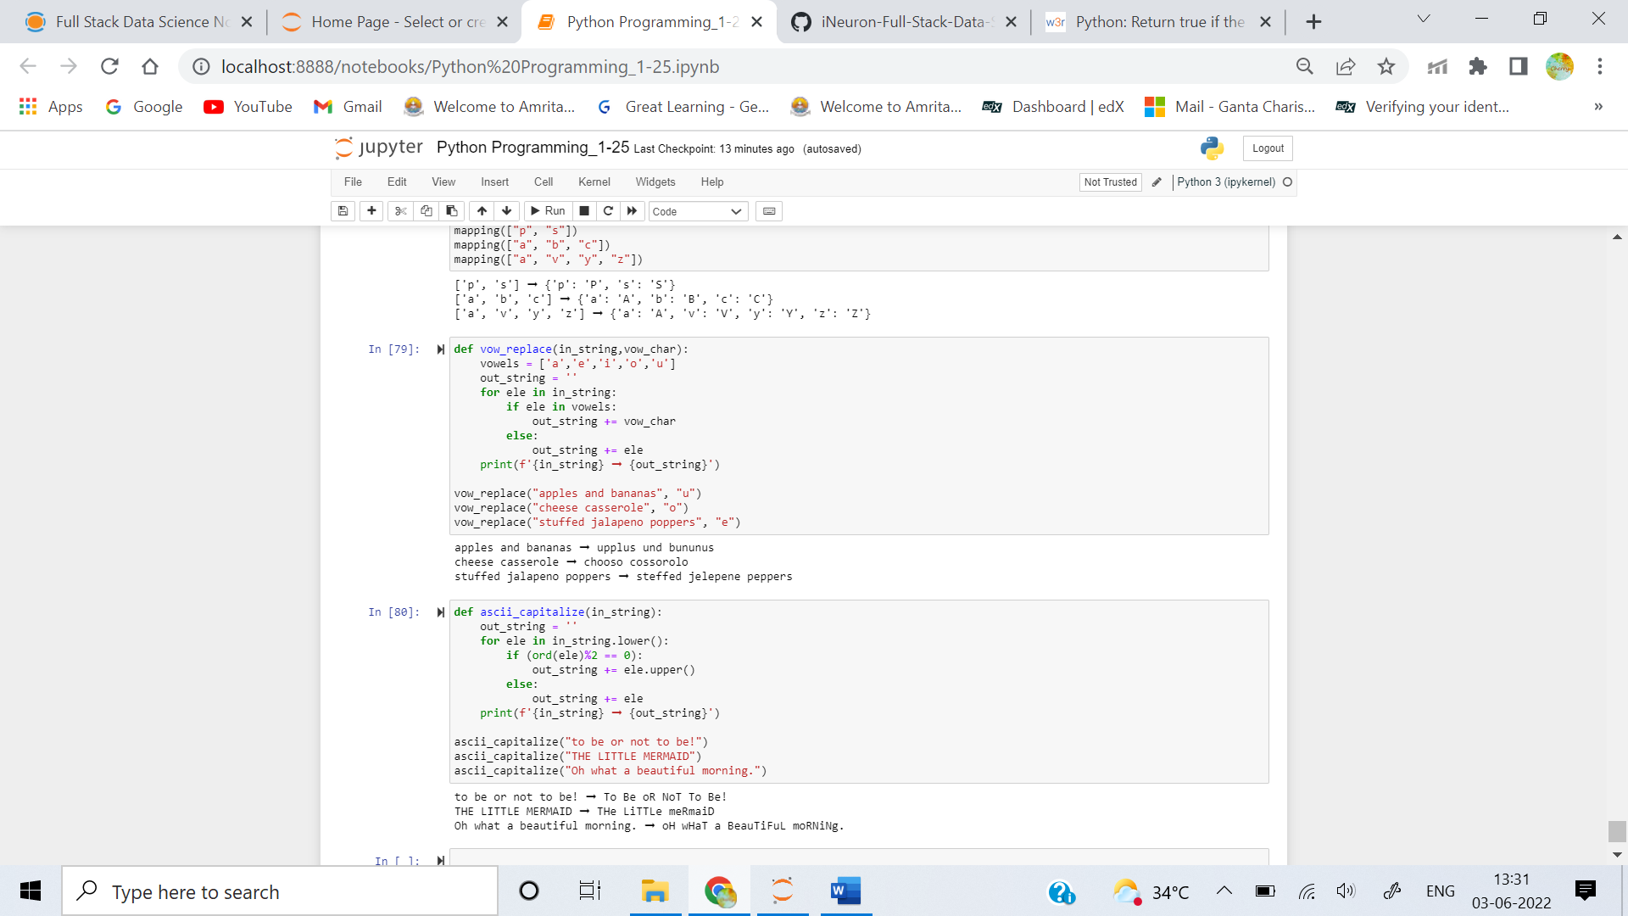

**Question5**

**Create a function that takes a string as input and capitalizes a letter if its ASCII code is even and returns its lower case version if its ASCII code is odd.**

### Examples

**ascii_capitalize("to be or not to be!") ➞ "To Be oR NoT To Be!"**

**ascii_capitalize("THE LITTLE MERMAID") ➞ "THe LiTTLe meRmaiD"**

**ascii_capitalize("Oh what a beautiful morning.") ➞ "oH wHaT a BeauTiFuL moRNiNg."**

